Storage Account- Add Azure search

1. Searching capabilities: if any one of the websites we need search engines that kind of functionalities we can bring from storage account
2. Regularly if want to develop the search engine for the website it is an extra effort if you need to bring the web site in the search engine and we need to enable this functionality so that website related index/monitoring will be started
3. Website homepage integrated with the given code
4. In the google index millions of websites will be there.

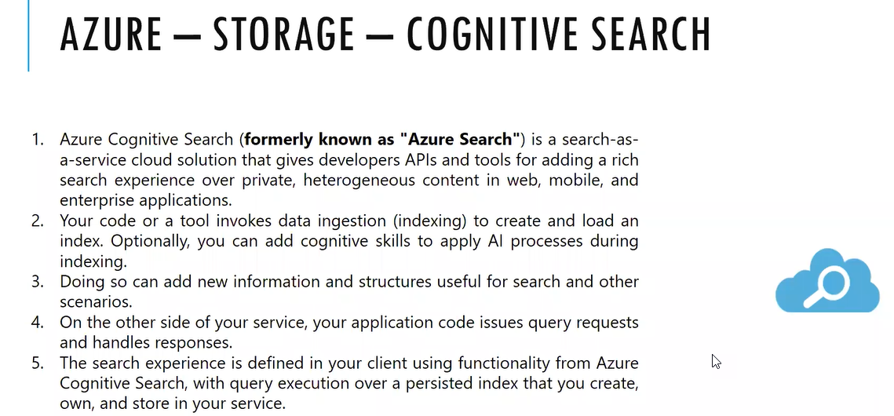

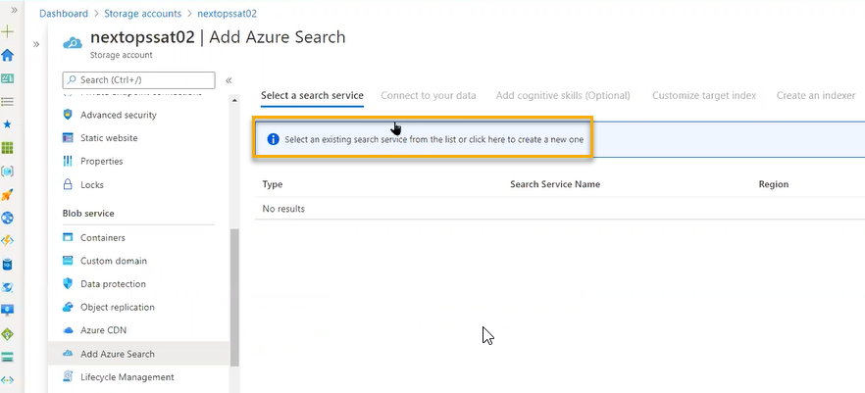

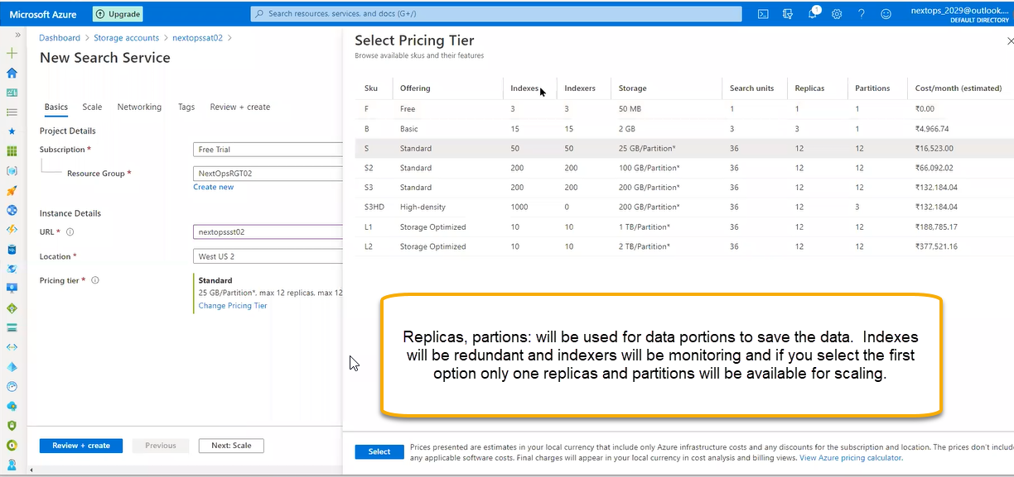

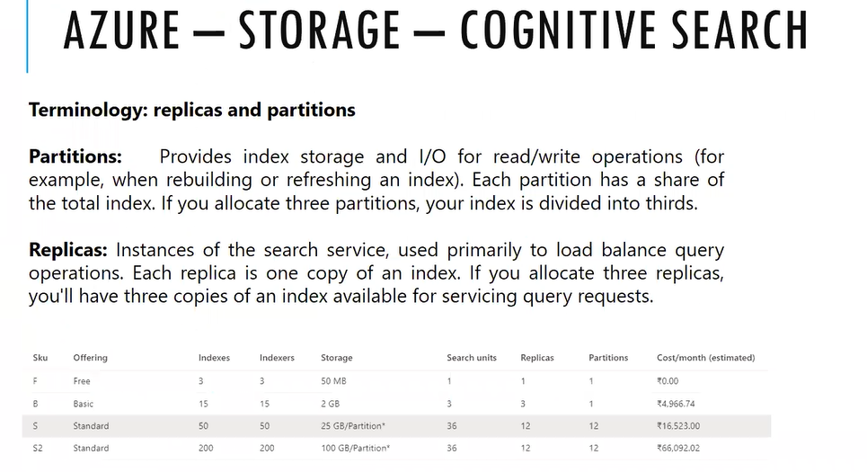

1. After creating with default options, we need to integrate this data with the created search engine

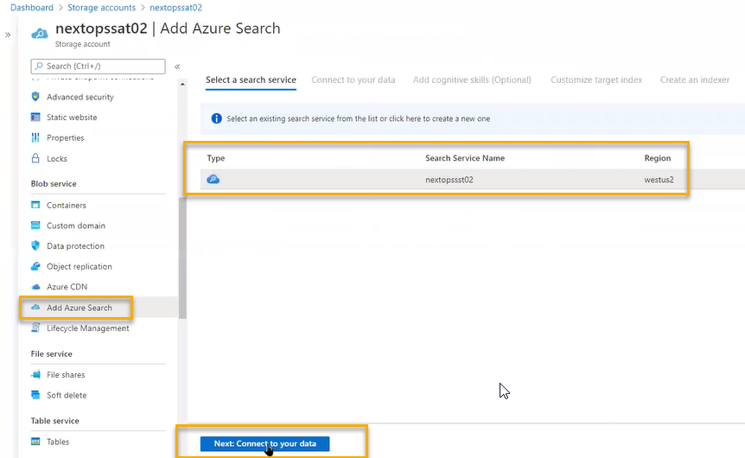

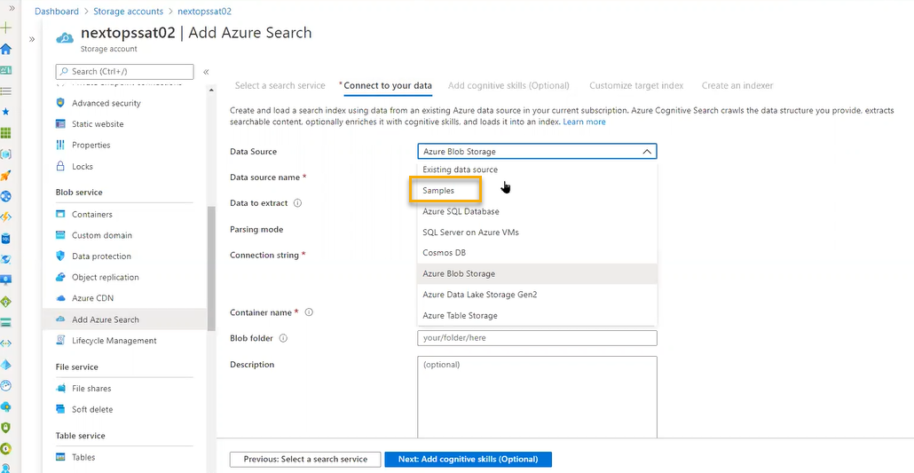

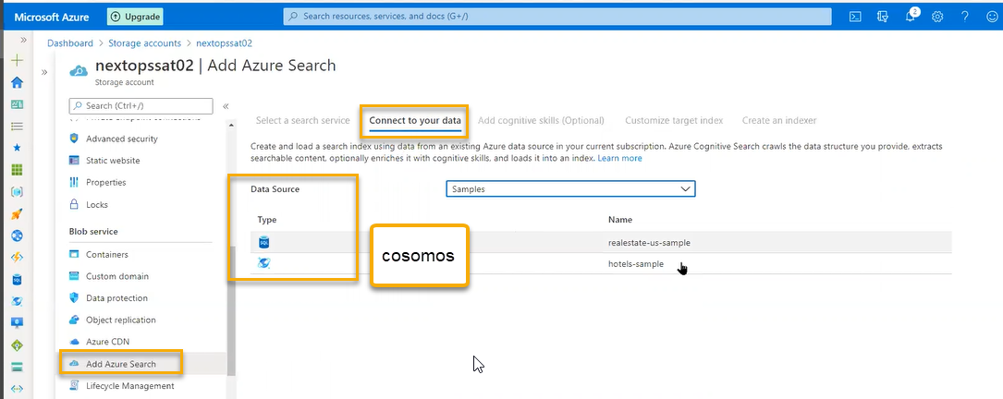

Select the default options and create

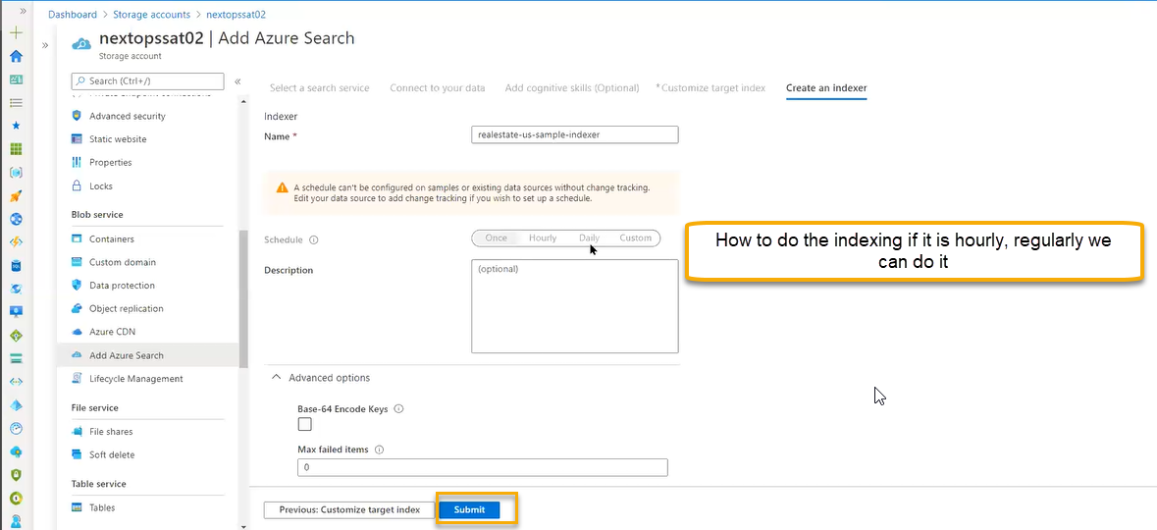

Search engine will be deployed

Lifecycle management

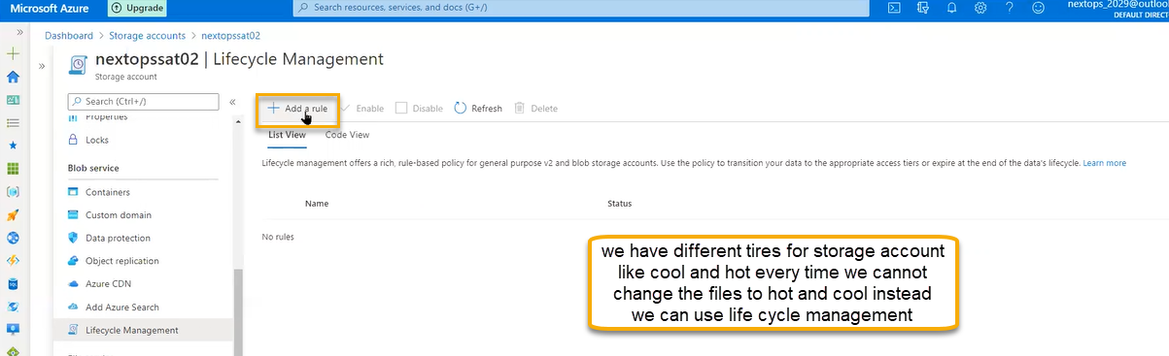

If you create one rule periodically it will run and

Rule scope: Apply rule to all blobs in your storage account

Limit Blobs with filter: if you add the filters then we can add extensions

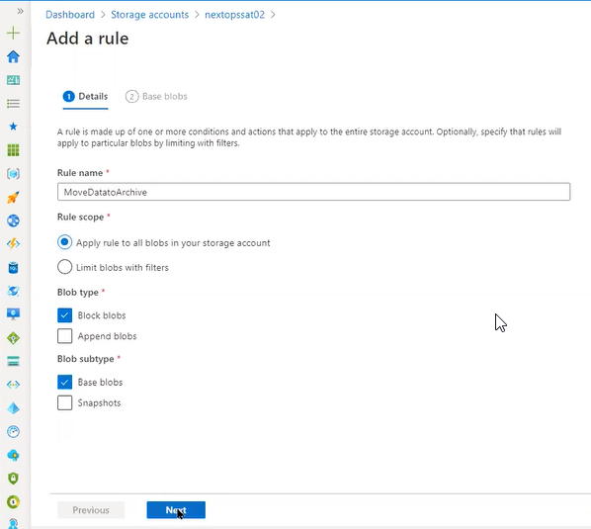

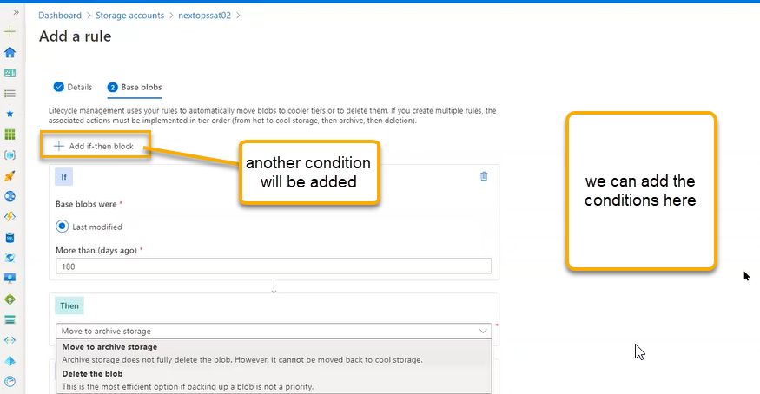

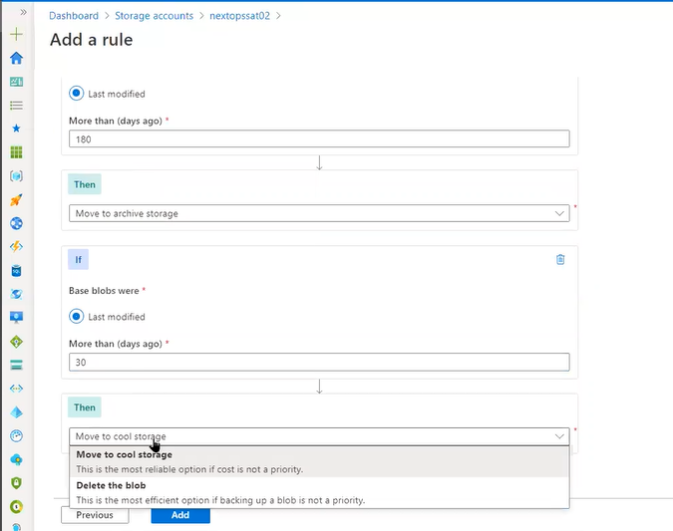

Containers will be maintained systematically NOT for file shares, tables and queues

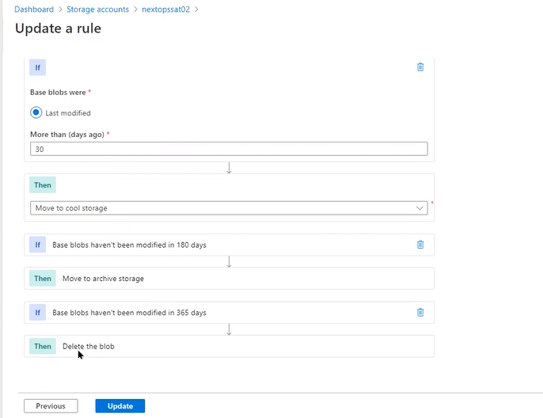

In these we can reduce the cost in the storage account

File shares to maintain the centralized way in the company we will use file share system

To maintain the file system, we need operating system like windows or linux and we need to apply the license and high security needed and we need admin in place

If you want to copy the files in the network system, we need to share the file so that file will be visibility throughout network

If you are sharing for the windows it follows SMB protocol

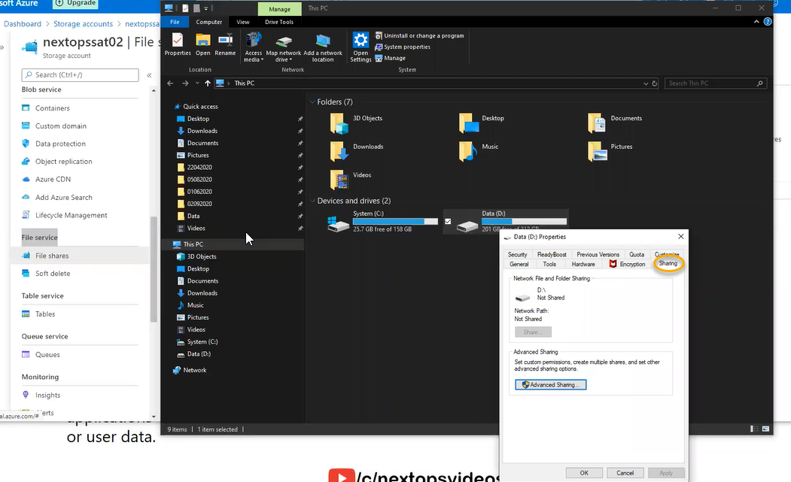

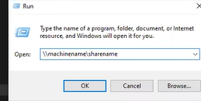

If you are sharing in Linux, then we need to use NFS protocol

Protocols depend on mounting

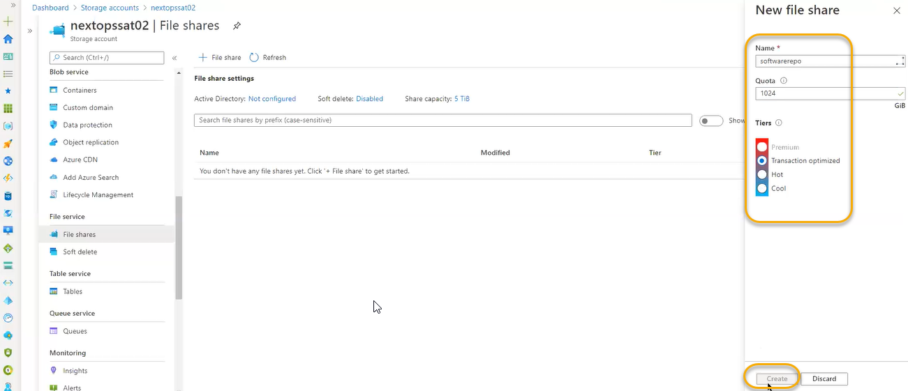

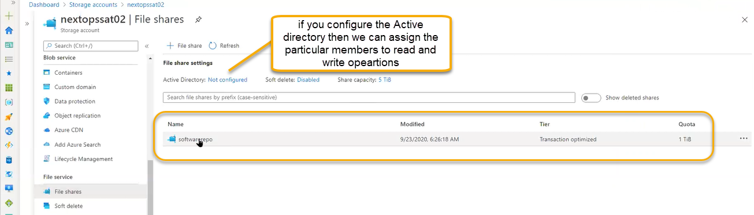

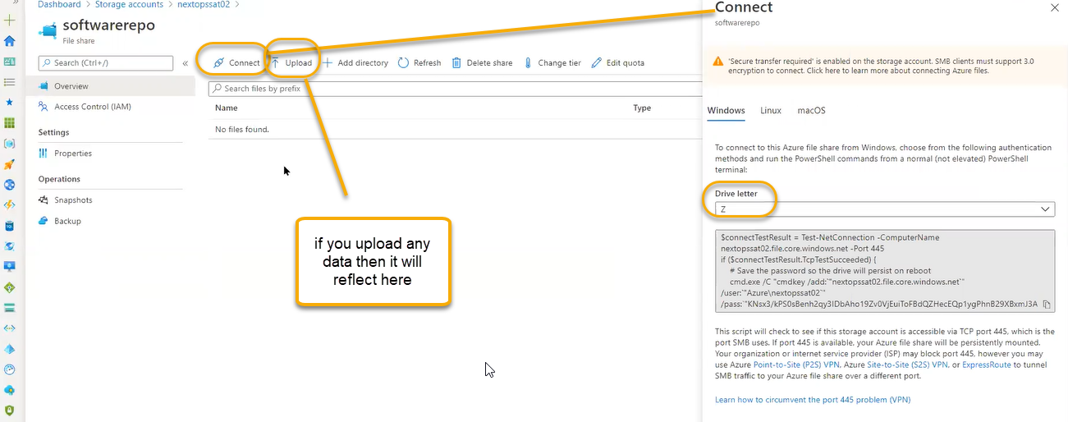

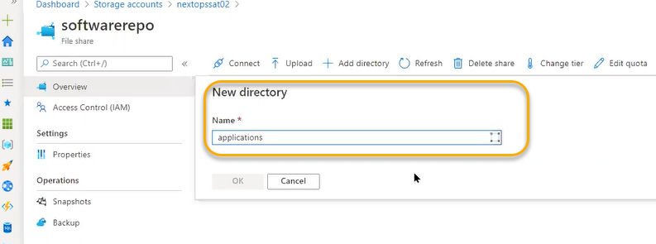

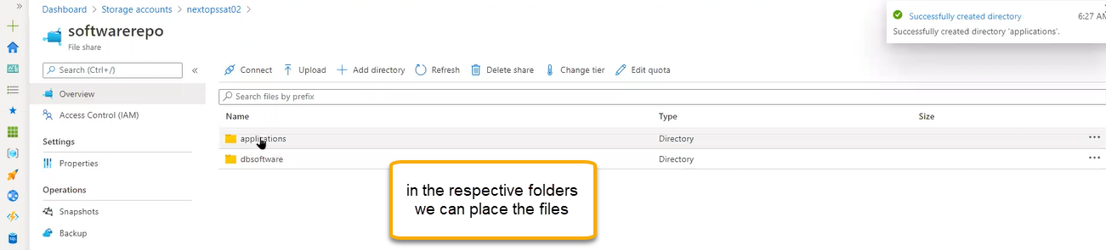

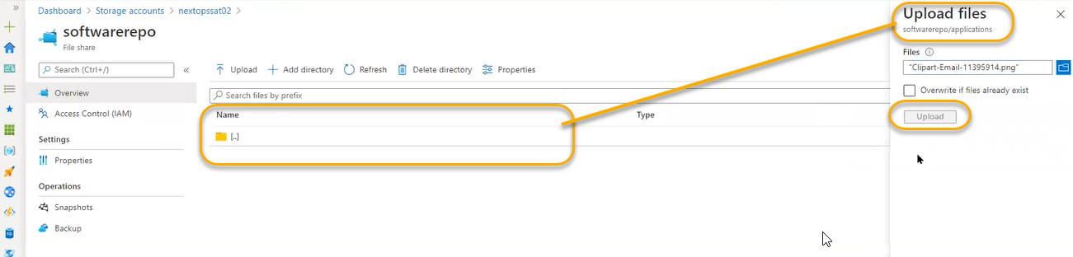

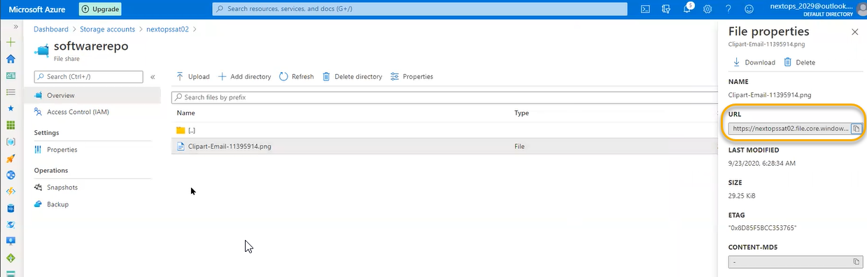

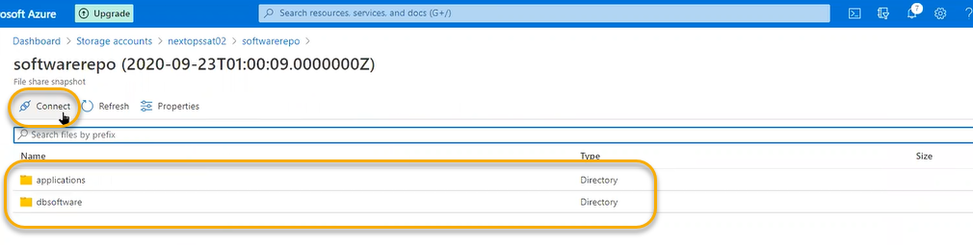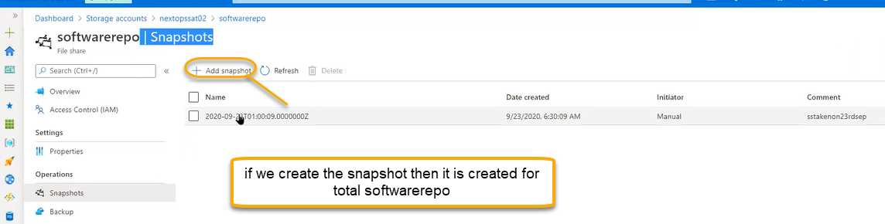

Soft delete: It is same as containers

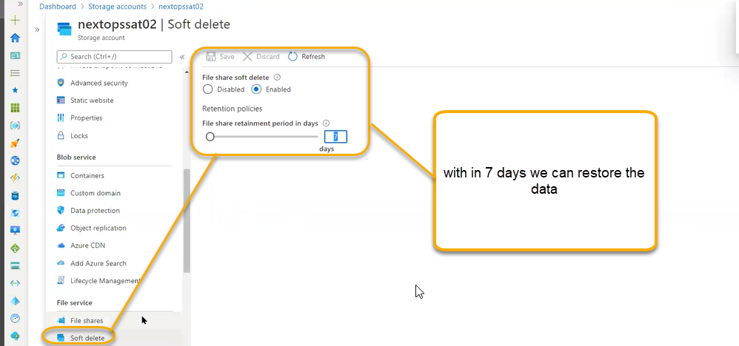

Fileshare

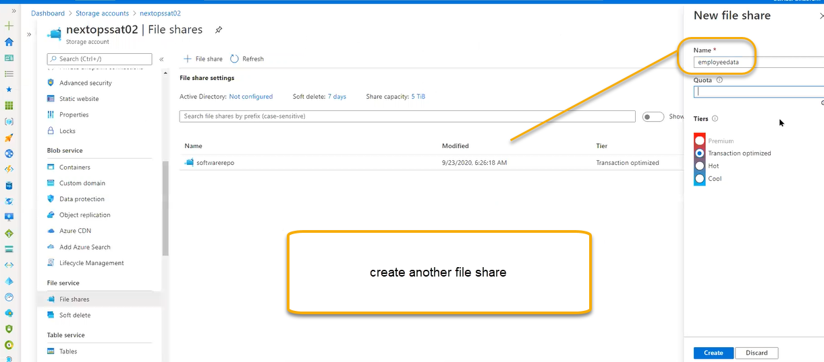

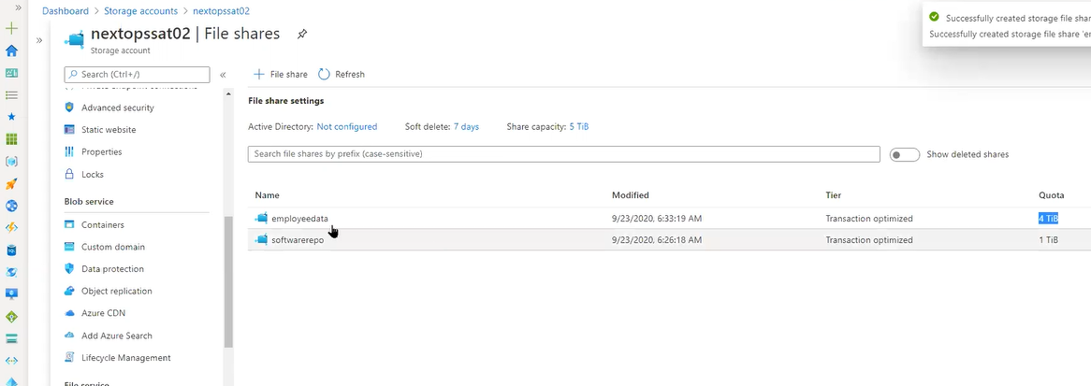

In that folder every employee we save the files in the desktop, My documents, pictures, videos, all data instead the saving in the local data we can save in the network share we have options in windows by means of joining the active directory which can control ourself

We can share the files in a centralized way so that all the files mounted in disk drive can be mounted in the cloud share we can see it

When employees tried to log in the upload process is constant bandwidth is high when employee logs off up to that certain point the changes will synched to server point. And if logins the files will be downloaded

If 100 people will logins then file server will become exhaust bottleneck issues, login issues , or bandwidth issue,

To overcome this azure has invented File sync we need to place it above the on-premises server

If he tries to login the process the data pick up not from azure, it will take from cache it is just like POP

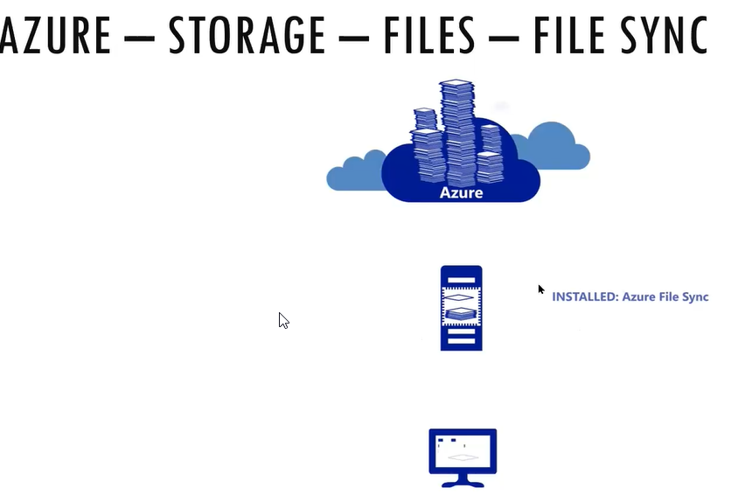

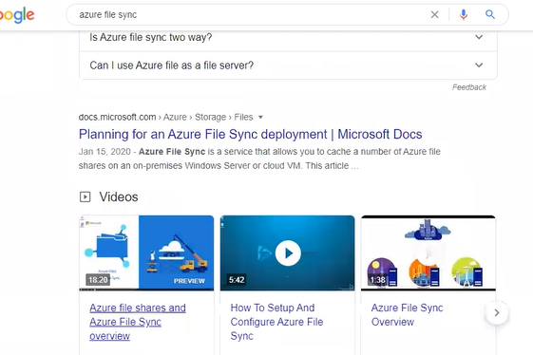

Tables

If we enable the diagnostics settings, serial logs in VM level then we can see that logs will be stored in storage account > Tables

From Azure admin we will get the request from developer to create the tables in azure we will create and pass that URL to development team

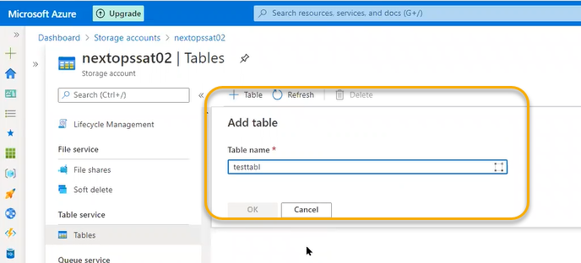

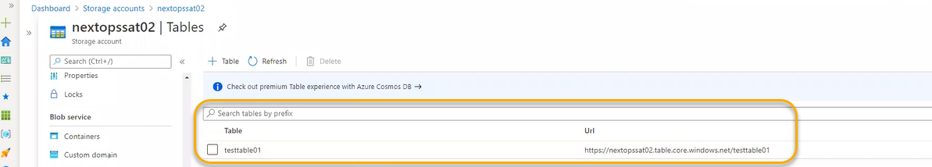

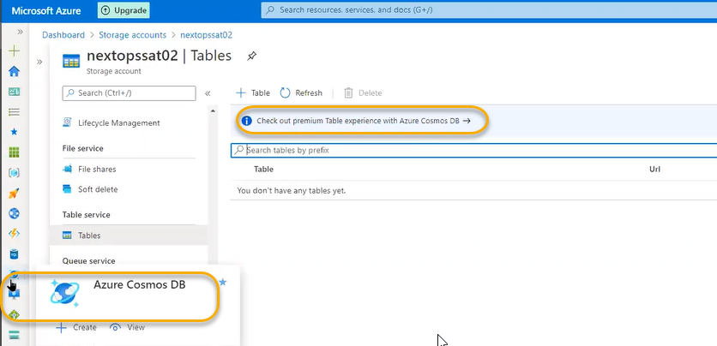

In the tables we will use non-structed SQL, if you are filling the form then submit then data will be saved in database which is non SQL. Based on the user input the fields keep on changing

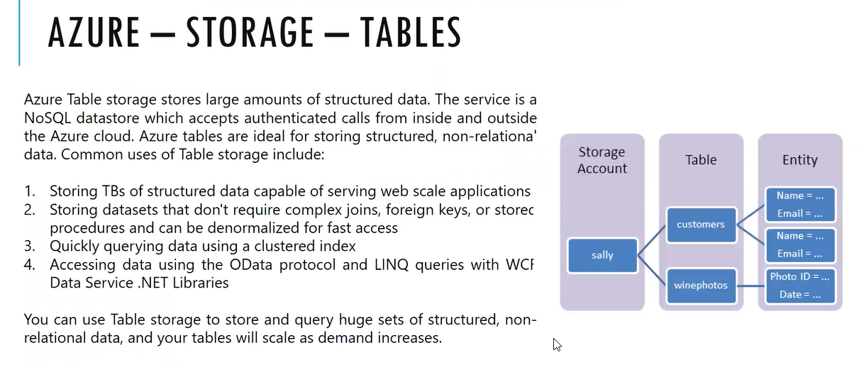

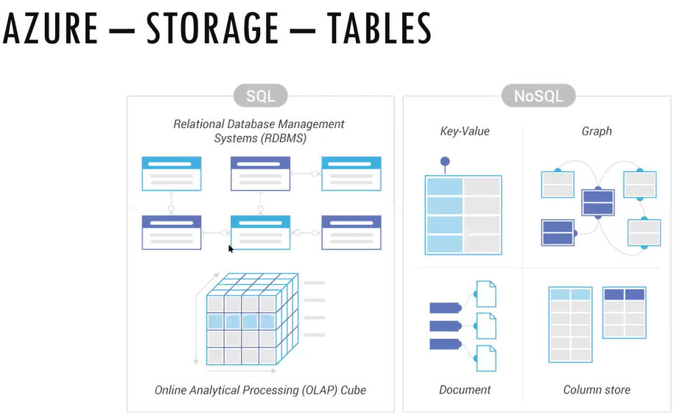

Queues: which is alternative to rabbitmq



In the mobile app we will get the notifications from different apps we need queuing mechanism that is called messaging queue(MQ)

It is a temporary placed folder

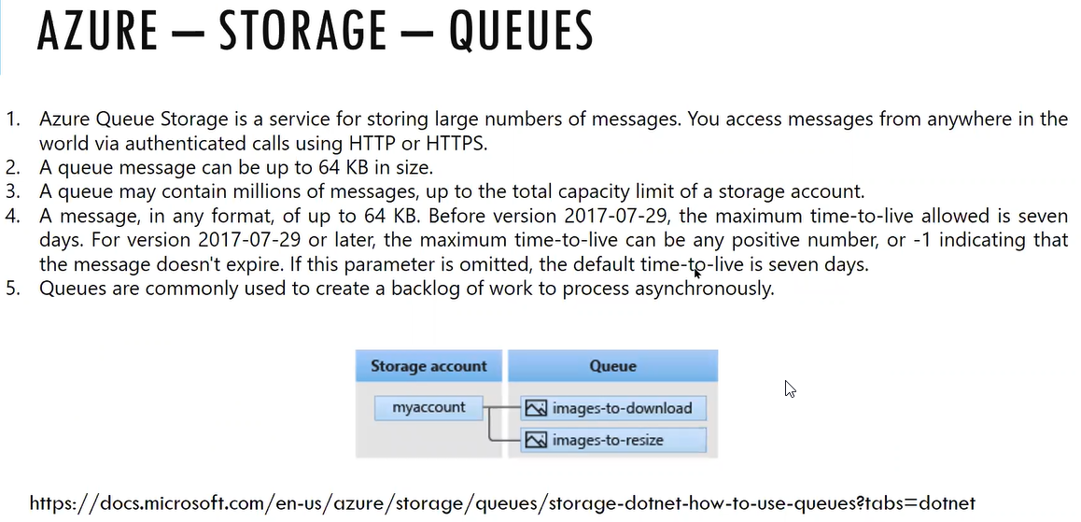

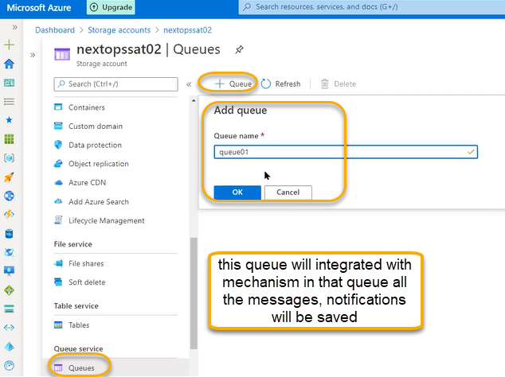

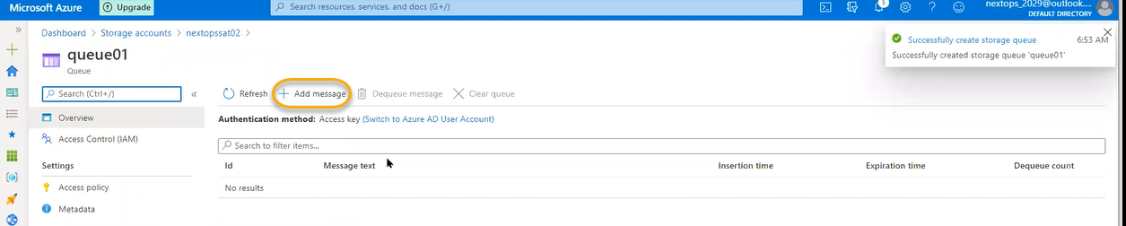

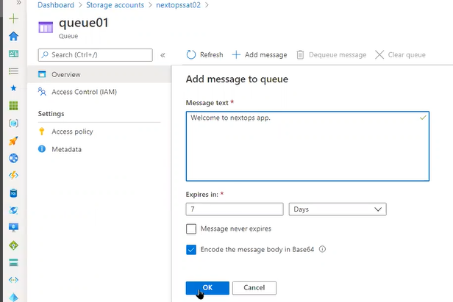

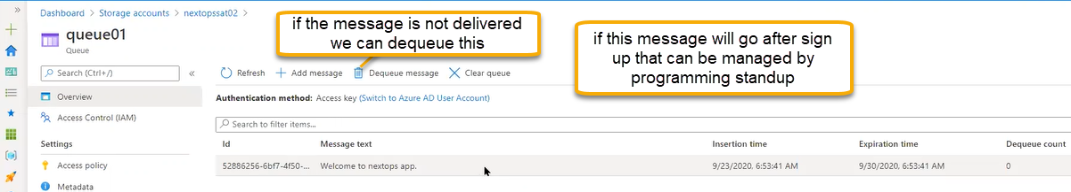

Tasks

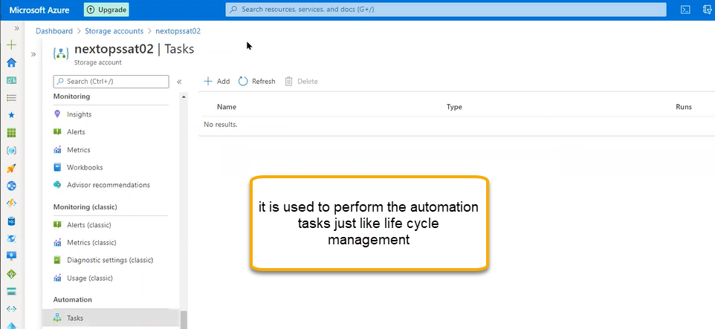

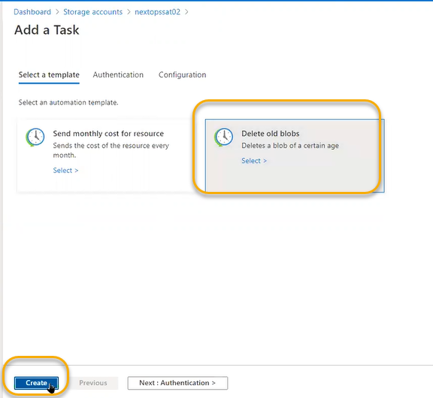

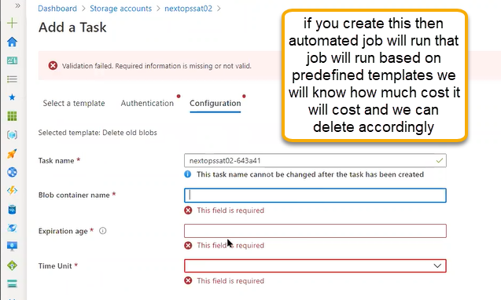

Connectivity check

